**An**

(E-COMMERCE PROJECT)

ON

DIGITAL ELECTRONIC

|  |  |  |  |  |
| --- | --- | --- | --- | --- |
| SR NO | ENROLLMENT NO | NAME | ID NO | EXAM NO |
| 1. | 22BCA24165 | RATHOD MANTHAN NARENDRABHAI | 22TBCA24051 | 6154 |
| 2. | 22BCA24020 | CHAVDA RONAKKUMAR CHANDRAKANT | 22TBCA24050 | 6027 |
| 3. | 22BCA24025 | DALVADI PARTHIV BIPINBHAI | 22TBCA24113 | 6032 |
| 4. | 22BCA24054 | DANTANI VISHAL MANSUKH BHAI | 22TBCA24027 | 6034 |

SUBMITTED TO

N.P.COLLEGE OF COMPUTER STUDIES AND MANAGEMENT

KADI

**Certificate**

I HEARBY CERTIFY THAT FOLLOWING GROUP MEMBERS:-

1. RATHOD MANTHAN NARENDRABHAI
2. CHAVDA RONAKKUMAR CHANDRAKANT
3. DANTANI VISHAL MANSUKHBHAI
4. DALVADI PARTHIV BIPINBHAI

Have Completed Case Study (E-commence Project) On **Digital Electronic** . BCA-508(B) E-COMMERCE TECHNOLOGY-III Subject Available In BCA Semester – V And It Is Part Of Syllabus, Approved By Kadi Sarva Vishwavidyalaya, Gandhinagar With The Specialization In E-COMMERCE.

Place : NPCCSM, Kadi Amita Nayi

Date : 14-11-2024 (project incharge)

* INDEX :

**Introduction :**

* Overview Of Project
* Key Features

**Features and Functionalities :**

* User Authentication
* Shopping System
* Payment System
* Admin Panel

**Technology Stack :**

* Front-end Technologies
* Back-end Technologies
* Database
* ER Diagram
* Data Flow Diagram
* Data Dictionary
* UI Design

**Conclusion :**

Project Outcomes

* **Introduction :**

The **Digital** **Electronic** is an online platform designed to sell a wide variety of electronic products, offering customers a convenient way to browse, compare, and purchase gadgets and devices from the comfort of their homes. The primary goal of this project is to create a user-friendly, secure, and efficient website that delivers a seamless shopping experience, catering to tech enthusiasts and everyday consumers alike.

The website offers key features such as product browsing, detailed product descriptions, user reviews, secure payment options, and order tracking. It is built with a modern tech stack, leveraging **HTML**, **CSS**, **JavaScript** the front-end, while **PHP** use as back-end language. A **SQL** database is used to store user and product information, ensuring scalability and flexibility.

**Key Features:**

* **Product Catalog**: A wide range of electronics categorized for easy browsing and search.
* **User Registration and Authentication**: Secure login and account management for personalized experiences.
* **Shopping Cart & Checkout**: A fully functional shopping cart system with seamless checkout.
* **Payment Integration**: Secure payment options with encryption for user safety.
* **Proposed System :**

**Purpose :** The Purpose Of System To Provide Best Electronic Item To Customer With Convenient Price And Large Amount Of Products

**Features and Functionalities :**

Our BCA-Electronics Provides This Variety Of Features For Improve User Experience And Enhance Business Operations.

**1. User Authentication :**

* **Sign-Up**: New users can register for an account by providing personal details such as name, email, and password.
* **Login**: Existing users can log in using their email and password.
* **Password Reset**: Users can request a password reset link if they forget their password.

2. **Product Listings :**

* **Product Search**: A search bar allows users to search for products by name or keywords.
* **Filters and Sorting**: Users can filter products by price range, categories, or popularity, and sort them by price or ratings.
* **Product Details**: Each product has a dedicated page with detailed information such as images, descriptions, price, availability, and customer reviews.

**3. Shopping Cart :**

* **Add to Cart**: Users can add products to their cart and adjust the quantity as needed.
* **View Cart**: The cart displays a list of selected products with details like price, quantity, and subtotal.

**4. Payment Gateway Integration :**

* Secure payment processing is implemented via third-party payment gateways such as **Stripe** or **Razorpay**.

**5. Responsive Design :**

* The platform is fully responsive, providing an optimized experience across all device sizes, including desktops, tablets, and smartphones.
* Mobile users can easily browse products, manage their carts, and complete the checkout process without any loss of functionality.

**6. Admin Panel :**

* **Product Management**: Admins can add new products, update existing ones, or remove products from the store. This includes managing product details like name, price, category, and stock levels.
* **User Management**: Admins can view and manage customer accounts, including banning or unbanning users as necessary.
* **Order Management**: Admins can view and update the status of all customer orders (e.g., processing, shipped, delivered).

3

**7. Email Notifications :**

* The system sends automated emails to users for key actions, including:
  + Account registration confirmation.
  + Order confirmation and invoice.
  + Shipment notifications with tracking details

**Technology Stack :**

**1. Front-end Technologies :**

* **HTML5**: Used to structure the content of the web pages.
* **CSS3**: For styling the website, ensuring a responsive and visually appealing layout.
* **JavaScript**: Provides interactivity on the client side, handling dynamic elements and user events.

**2. Back-end Technologies**

* **PHP:** The server-side scripting language used to handle the back-end logic of the application. It ensures dynamic content generation, database interactions, and seamless communication between the front end and the server.

**3. Database :**

* **SQL**: A SQL database used to store and manage all the application data, including user information, product details, orders, and transactions. SQL is chosen for its flexibility in handling unstructured data and scalability.

**ER Diagram :**

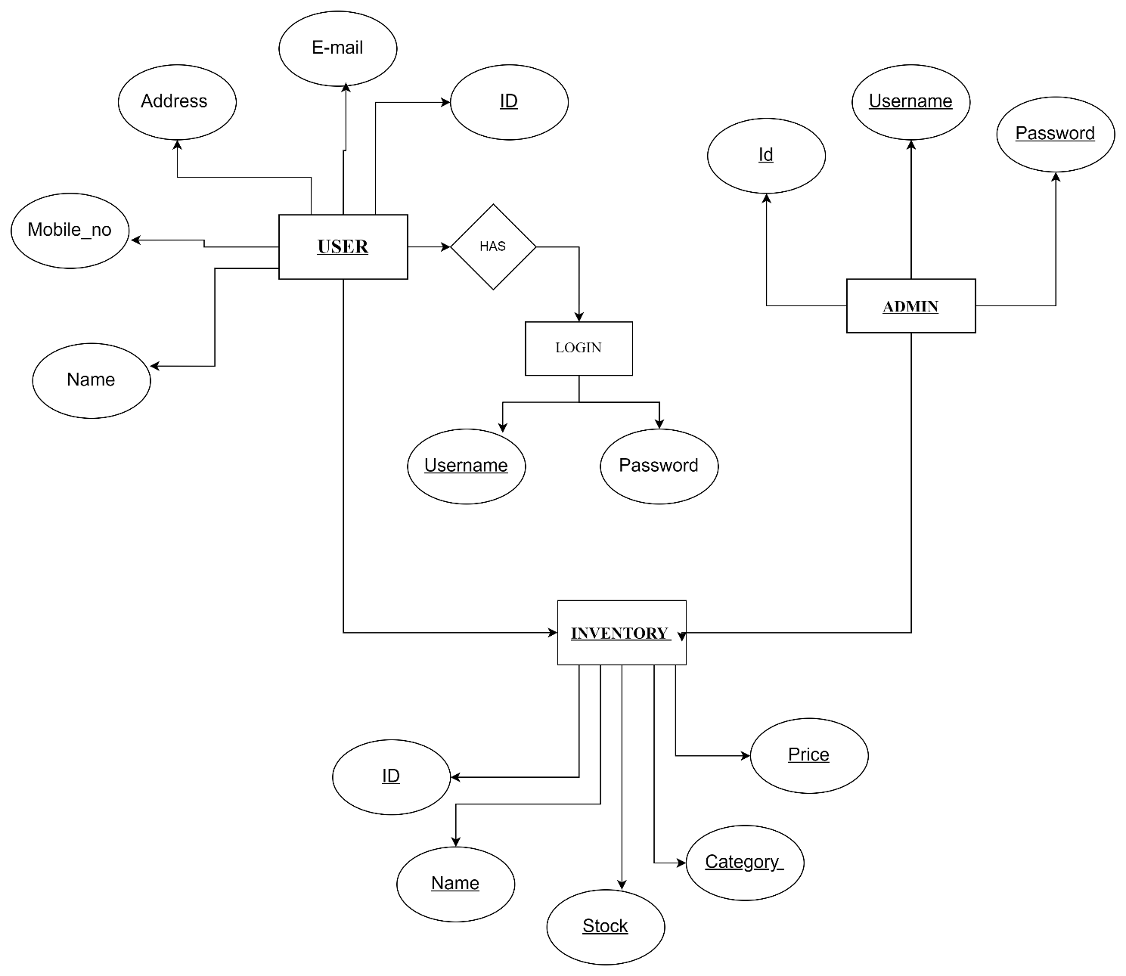

**DATA FLOW DIAGRAM :**

* Admin DFD :

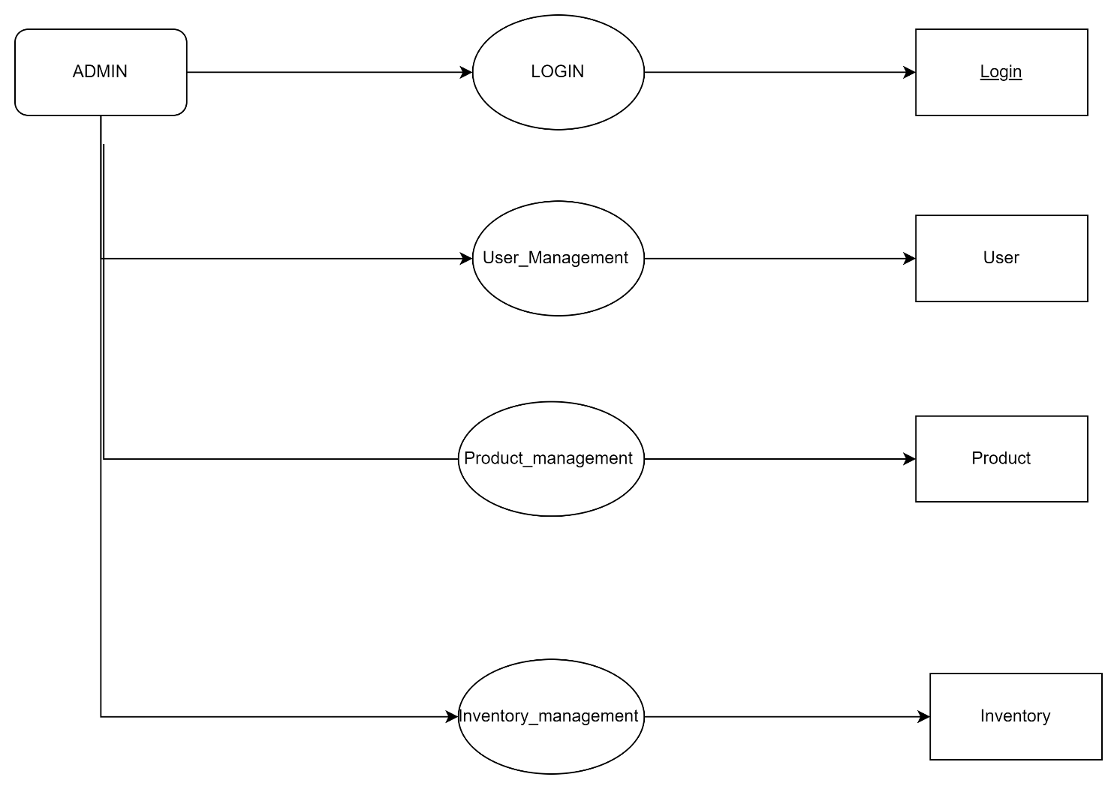

* User DFD :

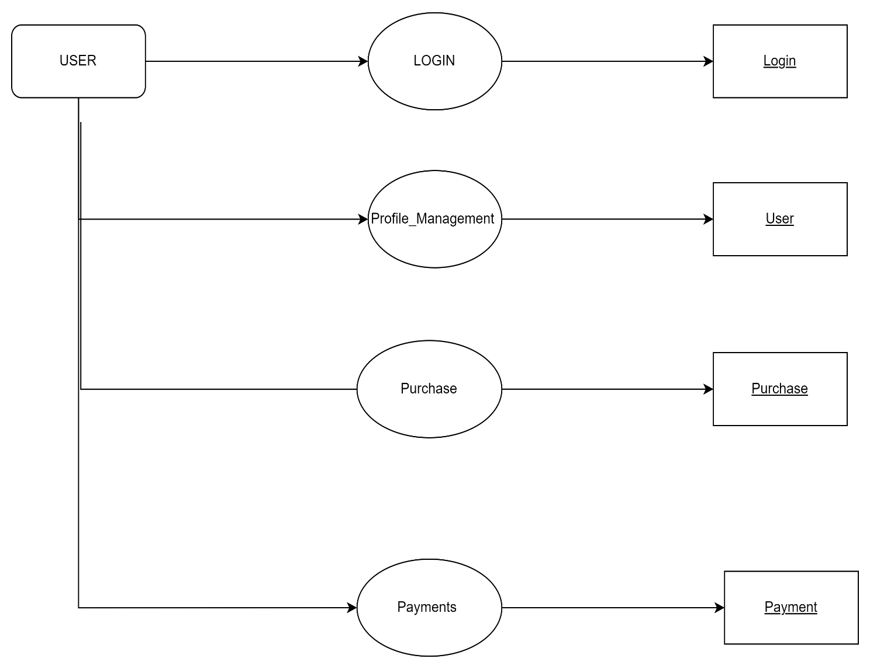

**DATA DICTIONARY :**

**TABLE NAME : ADMIN**

PRIMARY KEY : ID

|  |  |  |  |
| --- | --- | --- | --- |
| FIELDNAME | DATATYPE | DATA SIZE | CONSTRAIN |
| Id | **INT** | **11** | **PRIMARY KEY** |
| Username | **VARCHAR** | **50** | **NOT NULL** |
| Password | **VARCHAR** | **20** | **NOT NULL** |
| E-Mail | **VARCHAR** | **20** | **NOT NULL** |

**TABLE NAME : USERS**

Primary Key : Id

|  |  |  |  |
| --- | --- | --- | --- |
| FIELDNAME | DATATYPE | DATA SIZE | CONSTRAIN |
| Id | **INT** | **11** | **PRIMARY KEY** |
| Name | **VARCHAR** | **50** | **NOT NULL** |
| Username | **VARCHAR** | **50** | **NOT NULL** |
| Password | **VARCHAR** | **20** | **NOT NULL** |
| Address | **VARCHAR** | **40** | **NOT NULL** |
| E-mail | **VARCHAR** | **20** | **NOT NULL** |

**TABLE NAME : INVENTORY**

Primary Key : ID

|  |  |  |  |
| --- | --- | --- | --- |
| FIELDNAME | DATATYPE | DATA SIZE | CONSTRAIN |
| Id | **INT** | **5** | **PRIMARY KEY** |
| Name | **VARCHAR** | **10** | **NOT NULL** |
| Stock | **INT** | **10** | **NOT NULL** |
| Category | **VARCHAR** | **20** | **NOT NULL** |
| Price | **INT** | **5** | **NOT NULL** |

* **Conclusion :**

The **Digital Electronics** e-commerce platform offers a comprehensive solution for online electronics shopping, combining a robust back-end with a user-friendly front-end. Utilizing **PHP**, and **SQL** for the back-end, paired with **HTML CSS JS** for the front-end, the website ensures a seamless shopping experience for customers.

This platform empowers administrators to effectively manage products, categories, orders, and users while providing customers with easy navigation, cart functionality, and secure payment options. The focus on scalability and security ensures that the site can accommodate high traffic and data volumes.

In conclusion, **Digital Electronics** meets the needs of both customers and administrators, creating a scalable and reliable e-commerce solution for the electronics sector. Future improvements may include enhanced features like personalized product recommendations, real-time order tracking, and additional payment gateway options, further elevating user satisfaction.

* **ADVANTAGE**

* **24/7 AVAILABILITY** :- UNLIKE PHYSICAL STORES,AN ONLINE STORES OPERATE AROUND THE CLOCKS.
* **COST**-**EFFECTIVE** :- MAINTAINING AN ONLINE STORE GENERALLY LESS EXPENSIVE THAN RUNNING PHYSICAL STORE.
* **EASY**-**PAYMENT** **OPTION** :- ONLINE PAYMENT SYSTEM PROVIDE A VARIETY OF PAYMENT OPTION.LIKE:-CREDIT/DEBIT CARDS & DIGITAL WALLETS.
* **GLOBAL** **REACH** :- AN ONLINE WEBSITE ALLOWS BUSSINESS TO REACH A GLOBAL AUDIENCE.
* **CUSTOMER** **REVIEW** **AND** **FEEDBACK** :- ONLINE WEBSITE PROVIDE A PLATFROM FOR CUSTOMER TO REVIEW THEIR EXPERIENCE ABOUT PRODUCTS.
* **DISADVANTAGE**
* **SHIPPING COST AND DELAYS:-** SHIPPING ELECTRONICS CAN BE EXPENSIVE,SPECIALLY FOR LARGE ITEMS.
* **SECURITY CONCERN:-** ONLINE TRANSCATION INVOLVE SHARING SENSITIVE PERSONAL & FINANCIAL INFROMATION.
* **RETURN & WARRANTY ISSUES:-** RETURNING ELECTRONICS CAN BE COMPLICATED,SPECIALLY ITEMS LIKE LAPTOP,MOBILES,FRIDGE ETC.
* **HIGH COMPETITION:-** ONLINE ELECTRONIC FACES STIFF COMPETITION FROM BOTH LOCAL AND INTERNATIONAL RETAILER.
* 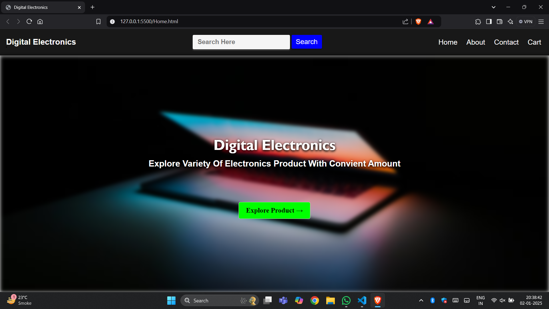**HOME PAGE UI :**
* **Features of Home Page :**

1. **CLEAR BRANDIND & LOGO**
2. **SEARCH BAR**
3. **NAVIGATION MENU FOR PRODUCTS**
4. **USER ACCOUNT MANAGEMENT**
5. **PRODUCT CATEGORIES**

* **Product Page :**

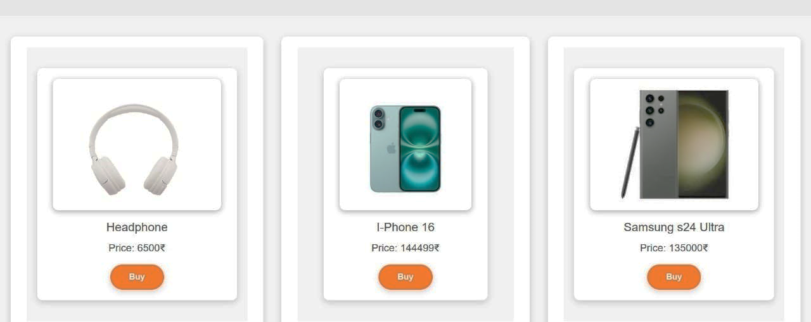

* **Product List :**

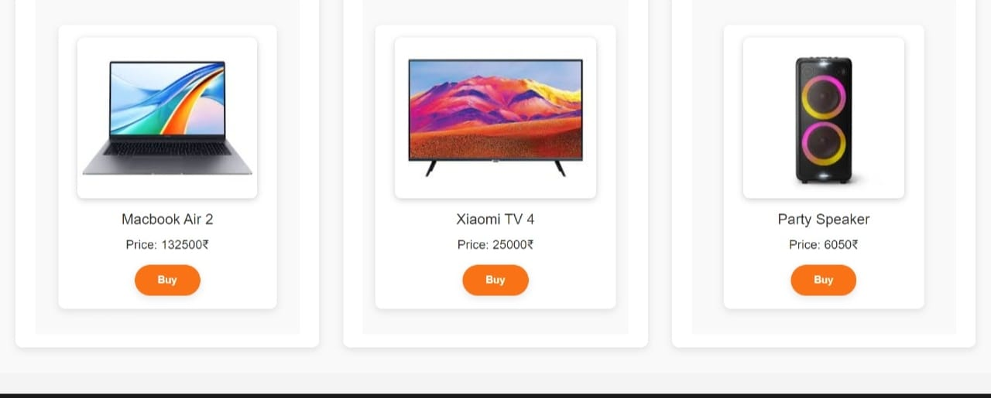

* **FEATURES OF PRODUCT PAGE**

**1. PRICE INFORMATIONS**

**2. AVAILABILITY AND SHIPPING INFORMATIONS**

**3. ADD TO CART OPTIONS**

**4. RETURN AND WARRANTY DETAILS**

**5. PRODUCT AVAILABILITY IN DIFFERENT VARIANTS**

* **Login Page :**

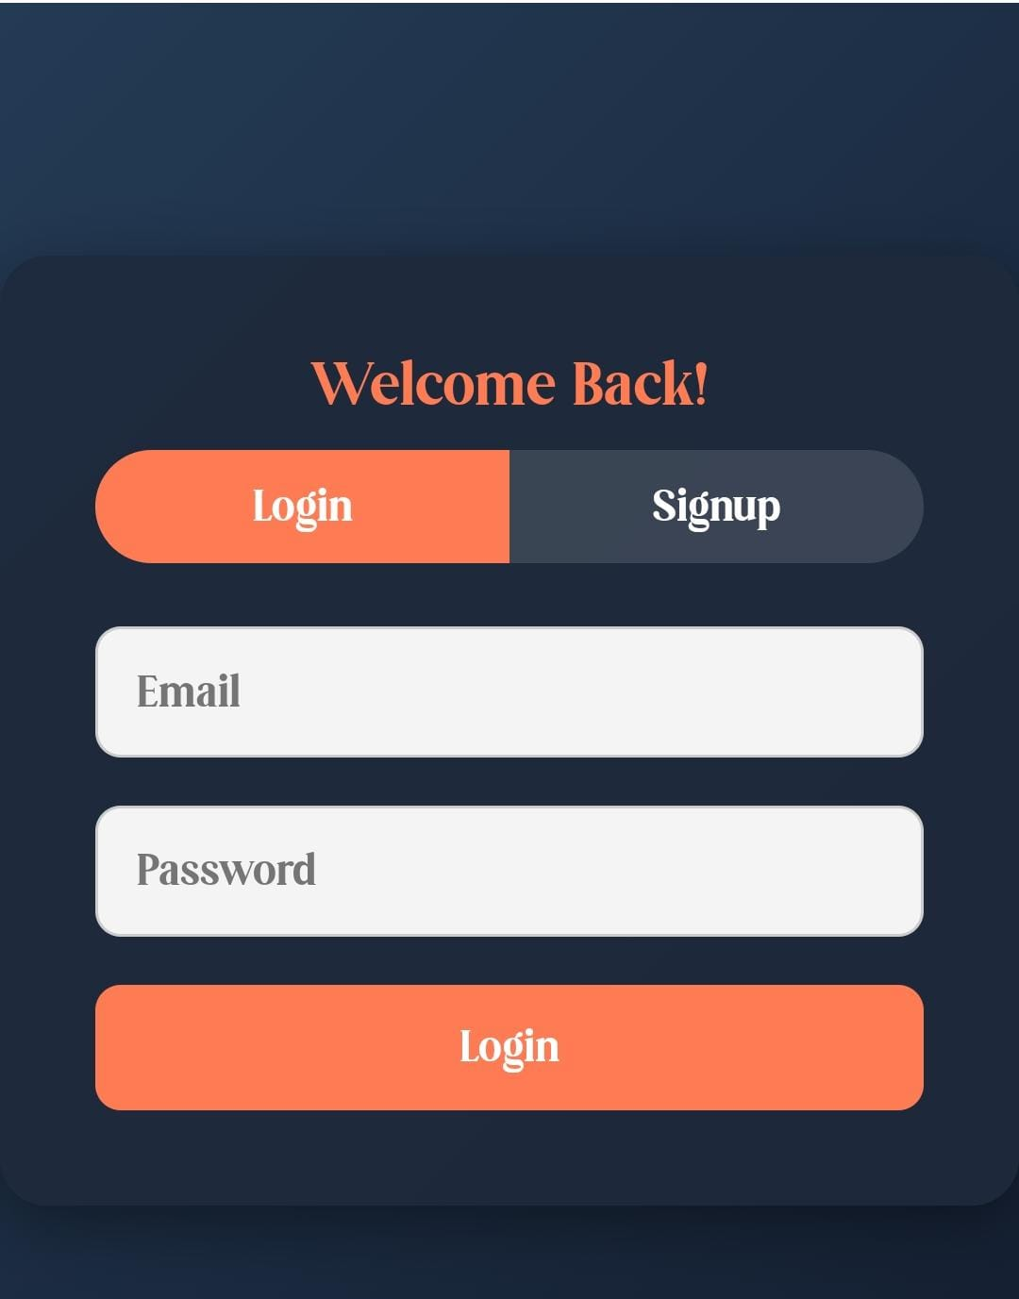

* **FEATURES OF LOGIN PAGE :**

**1. USER FRIENDLY INTERFACE**

**2. LOGIN FORM**

**3. FORGOT PASSWORD LINK**

**4. SECURITY FEATURES**

**5. ERROR MASSEGES**

* **ABOUT US :**



* **FEATURES OF ABOUT US PAGE**
* **COMPANY OVERVIES**
* **TEAM INTRODUCTION**
* **CUSTOMER COMMITMENT**
* **PARTENERSHIP & COLLABRATIONS**
* **CONTACT INFROMATION**
* **CONTACT US PAGE :**

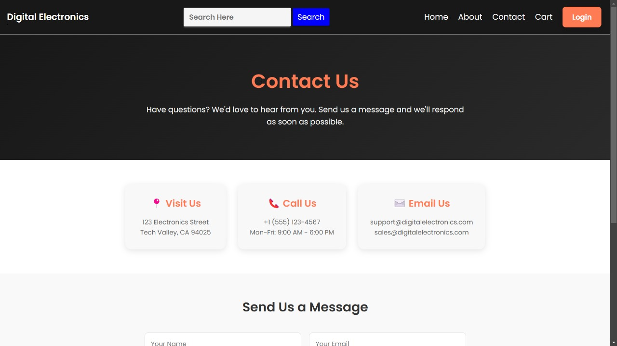

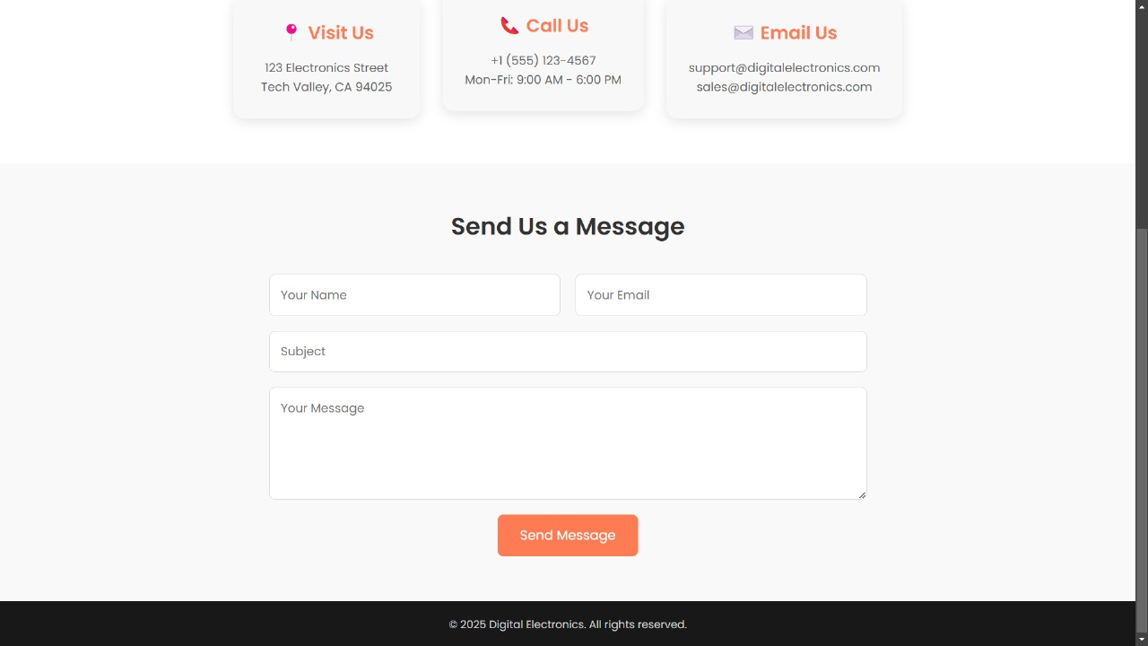

* **FEATURES OF CONTACT US :**
* **CONTACT FROM**
* **CONTACT DETAILS**
* **PHONE NUMBER**
* **EMAIL ADDRESS**
* **PRIVACY POLICY**
* **ADDITIONAL RESOURCES**
* **HELP CENTER**
* **INSTRUCTIONS**
* **CART PAGE :**

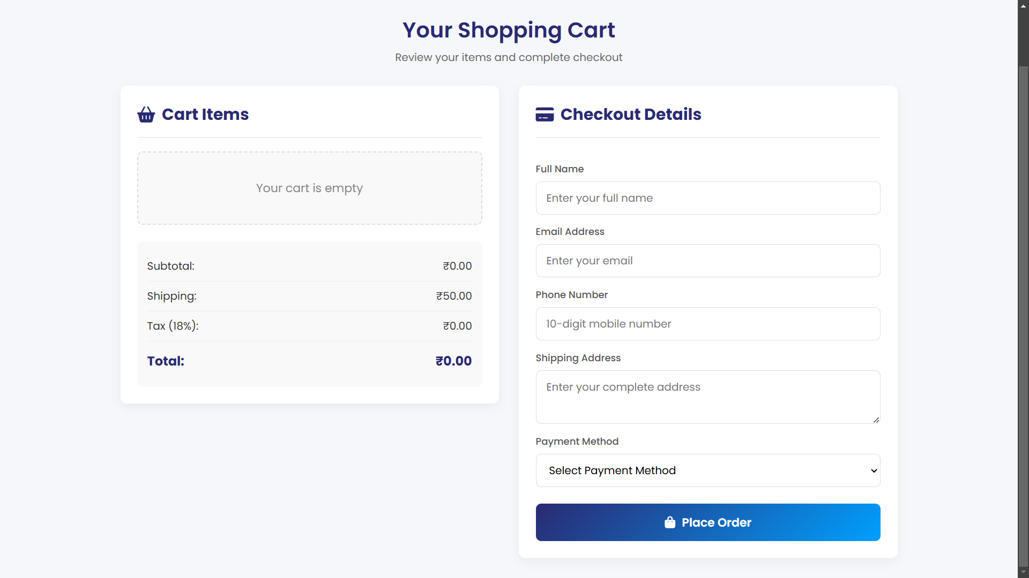

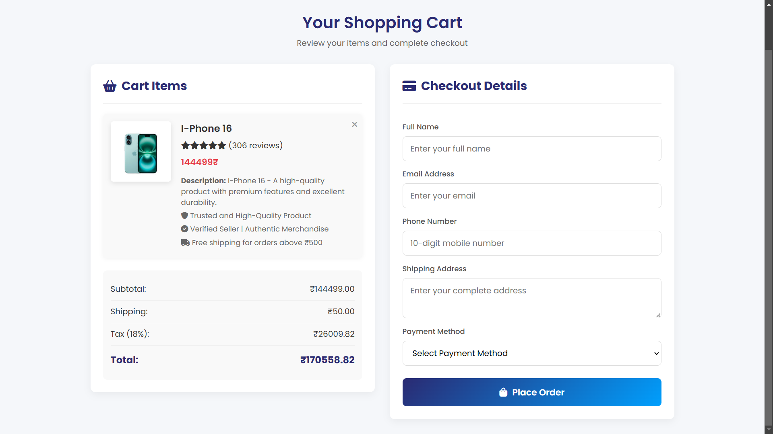

* **FEATURES OF CART**
* **Organized Customer Information Collection**
  + **Required Fields Include**
  + **Full Name**
  + **Email Address**
  + **Phone Number (10-Digit Format)**
  + **Shipping Address (with multiline Text Area)**
* **Payment Method Selection Dropdown**
* **Prominent "Place Order" Button**
* **FEATURES OF SIGN UP PAGE**
* **User Information Fields**
* **Username/account name field**
* **Email address field with validation**
* **Password field with strength indicator**
* **Password confirmation field**
* **Optional personal information (name, location, etc.)**